**BREAK EVEN ANALYSIS**

* The break-even analysis lets you determine what you need to sell, monthly or annually, to cover your costs of doing business.
* Break-even is a situation where you are neither making money nor losing money, but all your costs have been covered.
* Here the whole focus remains on Break Even Point (BEP).
* BEP is the point at which we find neither profits nor any losses, in the sense on reaching this point we find TR = TC

**Assumptions of Break Even Analysis:**

1. Total Cost is divided into Fixed and Variable Cost

Fixed cost will remain constant at all level of production

Variable Cost varies in direct proportion to the volume of the production.

1. Whatever produced is sold, we mean to say they are no closing inventories.
2. The selling price does not change with the change in the quantity of sale, in the sense we assume that there are no price discounts.
3. The firm is engaged in producing only one product.

**Significance of Break Even Analysis:**

* **Manages the Size of Units to be Sold-** With the help of break-even analysis, the company comes to know how many units need to be sold to cover the cost.
* **Budgeting and Setting Targets-** Since a company knows at which point a company can break-even, it makes it easy for them to fix a goal and set a budget for the firm accordingly. This analysis can also be practiced in establishing a realistic target for a company.
* **Monitors and Controls Cost-** Companies profit margin can be affected by the fixed and variable cost; therefore, with break-even analysis, the management can detect if any effects are changing the cost.
* **Helps Design Pricing Strategy-** Break-even point can be affected if there is any change in the pricing of a product. For example, if the selling price is raised, the quantity of the product to be sold to break -even will be reduced. Similarly, if the selling price is reduced, a company needs to sell extra to break-even.
* **Used in Decision Making:** Decisions like, Make or buy, most suitable and profitable Marketing Mix, Add or Drop Decisions were taken while taking the help of Break Even Analysis.

**Break-Even Chart**

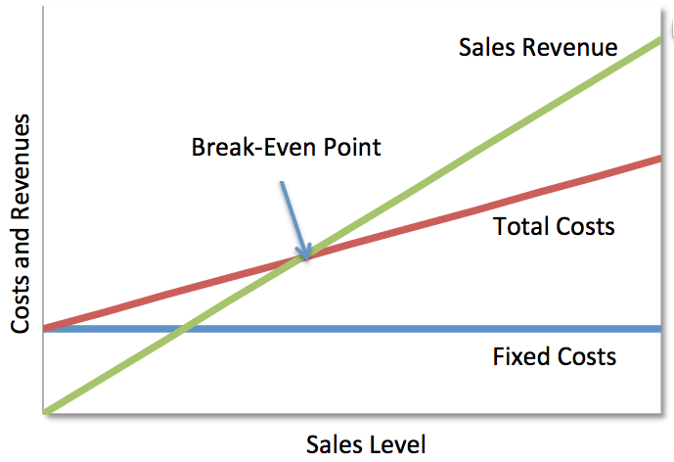

**Limitations of Break Even Analysis**

1. We usually go wrong with the assumptions.
2. It is assumed that total cost is divided in to fixed and variable costs along but in reality we even find that third variety of the cost called semi-variable or semi-fixed costs.
3. Right at the beginning it is assumed whatever is produced, the firm will be able to sell the same, but majority of the times we will be finding unsold units also called as inventories and never knew how to treat the same while calculating BEP.
4. We are assuming that selling price per unit will be the same, but find the presence of price discounts or concessions etc. So the shape of the total revenue curve need not be a straight line moving upwards.
5. Fixed expenses play a major role while calculating BEP, but we find these fixed expenses only in the short run, in other words break even analysis holds good only during short period. When we walk into long-run everything is likely to change including the so called BEP.
6. BEP is based on revenue (selling price) and cost (variable & fixed costs) components. Any time any change in either one or all the variables leads to a change in BEP too. So we got to take the decisions keeping this point in mind.
7. Multiproduct firms got to calculate BEP separately for each and every product. It might be little tedious to do the same.

**Cost Volume Profit Analysis (CVP Analysis)**

Cost Volume Profit Analysis explains the behavior of profits in response to a change in cost and volume. In other words, it is an analysis presenting the impact of cost and volume on profits. Commonly called as CVP Analysis, a manager can find out the level of sales where the company will be in a no-profit-no-loss situation with this analysis. This situation is called break-even point.

The breakeven point (level) and margin of safety fall under the broad domain of cost-volume-profit analysis (CVP Analysis).

In a similar fashion, CVP analysis can also explain the no. of units of sales required to achieve a particular targeted operating income.

**Example with Formula**

Cost Volume Profit analysis thinks like a number line wherein it starts with negatives, then comes 0 and then positives. Similarly, with the increasing level of sales, first will see a phase of losses, second a breakeven and third where we make profits. The first priority of any businessman is to safeguard its investment and therefore tries to save the capital shrinkages. This is possible if a business achieves the [breakeven point](https://efinancemanagement.com/financial-analysis/difference-between-breakeven-point-vs-margin-of-safety).

**Importance:**

* This analysis is important because it is required to calculate the amount of sale to break even (which is the most important question for every business)
* Assess whether the firm is capable of achieving that sale.
* To estimate required initial investment
* CVP Technique is used to evaluate Investment proposals.
* It sets the base for planning the marketing efforts of a business
* It helps in setting up the basis for budgeting activity.